Orator’s Report
on the 4th Degree
Secret Master
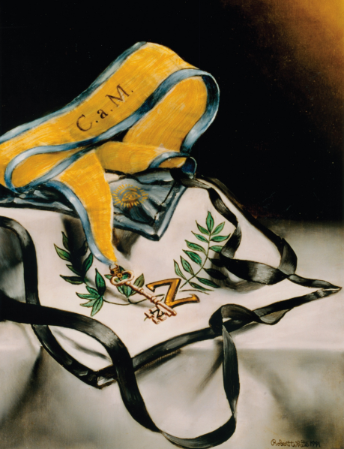
May 12, 2021
The Apron and Collar are white with black piping and black straps symbolizing the pain suffered upon hearing of the Master Hiram's death and the loss of the Word. In its center is a “Z” surrounded by two crossed branches of laurel and olive leaves.
Bremerton Valley of the Scottish Rite
The Legend: The 4th thru the 14-degree, deal with various aspects of the Hiramic legend propounded in the 3rd degree, examining aspects such as duty, faithfulness, and the knowledge and virtues that characterize a Mason. These are known as the “Ineffable Degrees” because they treat the rediscovery of the ineffable name of God. The Degrees teach the quest for light, and inspire the awakening of one’s moral and intellectual nature and are based on how Hiram Abiff helps King Solomon build his Temple as given in the Bible books: 1 Kings chapter 5 to 9 and 2 Chronicles chapter 2 to 7.
The Setting: The Lodge of Secret Masters represents the meeting of the Princes of Israel at the death of Hiram in or near the partially completed Temple on the Mount in Jerusalem. The work in the Temple has been suspended. In the East there is a balustrade with a door called The Holy of Holies. The hangings and the covering of the Altar are black and sprinkled with silver tears reminding us of the loss of the True Word.
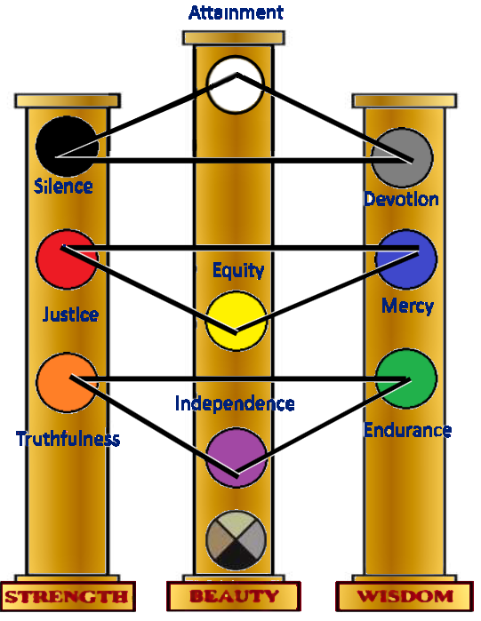
The Ritual: The Fourth Degree opens in the sadness and sorrow that followed the untimely death of our Grand Master Hiram Abiff. The ceremony has no plot; the purpose is not so much to illustrate virtues but to lay the foundation for the entire Scottish Rite degree system.
The candidate learns that a man is not fit to commence the ascent toward the heights on which Truth sits enthroned without first appreciating and embracing the value of Truth itself, and the Virtues. Our mission as Masons is to serve our fellows, our country and mankind, based on the nine great Masonic virtues of the Kabbalah Tree of Life: Truthfulness, Endurance, Independence, Justice, Mercy, Equity, Silence, Devotion, and Attainment.
Duty and its importance in Scottish Rite Masonry are highlighted in the ceremony. The duties of a Scottish Rite Mason are not fulfilled in the expectation of earthly rewards or honors, but in the simple hope of personal satisfaction. These duties make up the path that leads to the goal of the Masonic quest for the True Word. The candidate has started a great journey. However, this is not an easy journey.
The Lecture: The Initiate is given the key to self-knowledge, and his feet are set firmly upon the path which leads there, and the way to achieve that goal is pointed out. He must learn to work for the work’s sake, without desire of approbation or reward. It is the duty of a man who seeks and accumulates greater knowledge to know and practice those ethical and moral principles which demonstrate Man’s highest, and most noble nature. As we begin our climb to the skies of spiritual knowledge, our eyes are anointed to discern truth from error. The Initiate is given the Key to the Mysteries, and introduced to the Kabbalah as a system of mystical thought used by the Kabbalists to illustrate the world and all its marvelous parts. And it is also introduced as a key to the symbolic language necessary for reading and comprehending the deeper meanings of Scottish Rite and Masonic symbolism in general. The doctrine of the 27th Degree is chiefly derived from the Kabbalah. (In the novels: “Lost Symbol”, “The Da Vinci Code”, and “Origin”, Robert Langdon, author Dan Brown’s protagonist, illustrates the importance of the Zohar, the classic book of Kabbalah.)
The Initiate is taught to practice Silence, Obedience, and Fidelity. The mason who can always keep faith in God and his Masonic brother is well on his way to discovering the Royal Secret and the Lost Word. Albert Pike says that learning "must be traced back to the sources located in the very remote past and there the origin and meaning of Masonry will be found." Thus, the teachings of Masonry are not to be taken lightly or superficially acquired after they are taught.
This is to inform the initiate that Freemasonry is not a social club but an aggregate of good men looking for wisdom and the True Word of God.
THE MORAL TEACHING of this degree is that we live in peace with our own conscience and are honored by good people when we perform our duties honestly and diligently. When honesty, diligence, justice and brotherhood do not exist, freedom and independence are meaningless. Masonry values man as a person.
The efforts made to discover the origin of the Hiramic legend show that, while the Masonic legend is comparatively modern, its underlying principles run back to remotest antiquity. From these associations it is evident that Hiram is to be considered as a prototype of humanity. As Adam after the Fall symbolizes the Idea of human degeneration, so Hiram through his resurrection symbolizes the Idea of human regeneration.
DUTIES: Practice Silence, Obedience, and Fidelity, not to be fulfilled expecting reward, but personal satisfaction.
- Silence warns us of the demands that we may make to a truly needy Brother, demands that can be measured far beyond simple human charity. It is one of the main disciplines we must undertake in pursuit of the reconstruction of God’s temple within ourselves.
- Obedience is not blind towards tyranny, but is the very submission of the individual will to the necessary demands of living in society.
- Fidelity is one of the highest virtues among the ancients. We must always strive to keep faith in God and in our Brethren, otherwise our obligations would be meaningless.
LESSONS: The teachings of Masonry are not to be taken lightly. Learning far surpasses physical monuments.
FOR REFLECTION: Can one command someone who does not know how to obey?
IMPORTANT SYMBOLS: The black collar with the silver tears, the service of Adonhiram, the ivory key, the shining star, the laurel branch and the olive leaves.
Adapted from the Spanish version of Rex R. Hutchen’s book A Bridge to Light

